**Automatic magazines metadata filling**

**(completarea automata a metadatelor in reviste)**

“Automatic magazines filling” suppose to have a program that is capable to recognize in other images or documents the appropriate data and metadata. In this case we have a data base with images of articles, magazines, newspapers, screenshots which will be given as training data for our program. To understand better how it works, the image below shows an example.

**Image1**

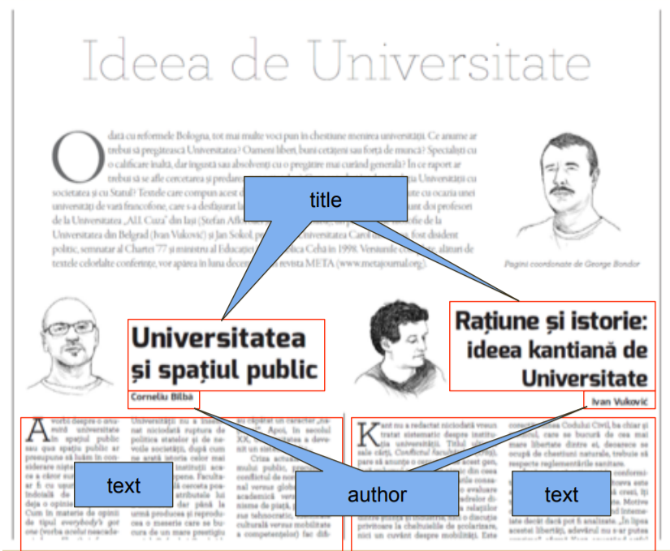

From my point of view this program will save a lot of time for that people who search a specific information and want to see everything about it. Earlier, when the people didn’t use the computer, it was quite difficult to find an information through the big mountains of newspapers, magazines etc. Now when we have so many opportunities it is much easier to filter the data, but you need a program to do it for you. And now this is what we are going to do.

